**Difference between HTTP1.1 vs HTTP2**

HTTP/1.x vs HTTP/2

HTTP2 Vs. HTTP1 is not a debate at all. HTTP2 is much faster and more reliable than HTTP1. HTTP1 loads a single request for every TCP connection, while HTTP2 avoids network delay by using multiplexing.

HTTP is a network delay sensitive protocol in the sense that if there is less network delay, then the page loads faster. However, an impressive increase in network bandwidth only slightly improves page load time. This is key to understanding the differences in performance efficiencies between the different versions of HTTP. Back in the day when people used dial up modem’s web pages were simple and it was the actual data transfer between the server and the client that contributed towards the largest chunk of the page load time. Today the actual downloading of resources from server takes a negligible portion of the total page load time due to the tremendous increase in bandwidth availability. It is the time taken to establish the TCP connection and making requests that impacts performance. It was initially recommended to use only two connections per hostname but today most browsers use six connections per hostname. When we talk about http vs http2 in terms of performance it is important to note that a lot of performance optimizations adopted by HTTP/1.1 introduced complexities in terms of developmental efforts as well as network congestion that HTTP/2 attempts to address.

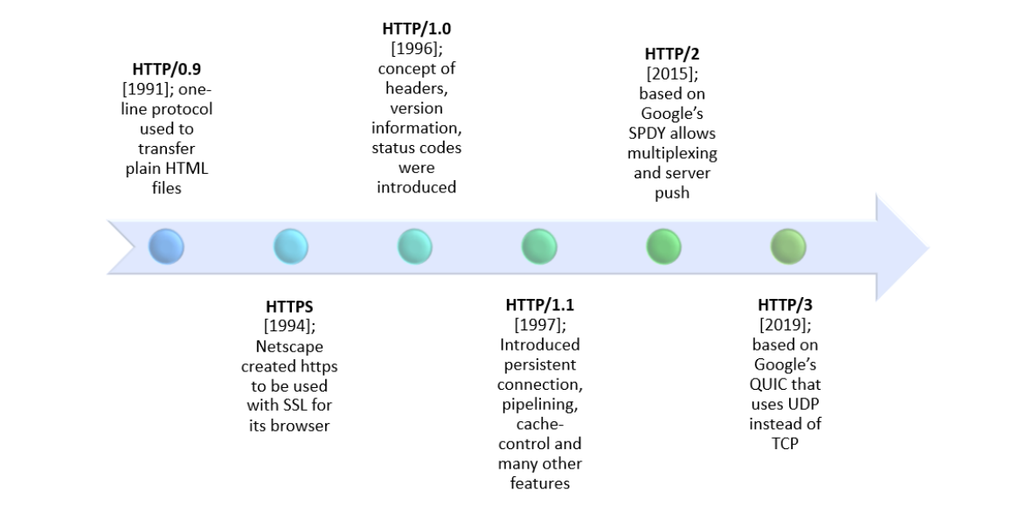

HTTP/3, the next version in the series, is based on Google’s QUIC which, unlike its precursors is a drastic shift to UDP. Given the gradual adoption rate of HTTP/2, HTTP/3 with its security challenges (that comes into play the moment we switch from TCP to UDP) is expected to face some difficulties.

